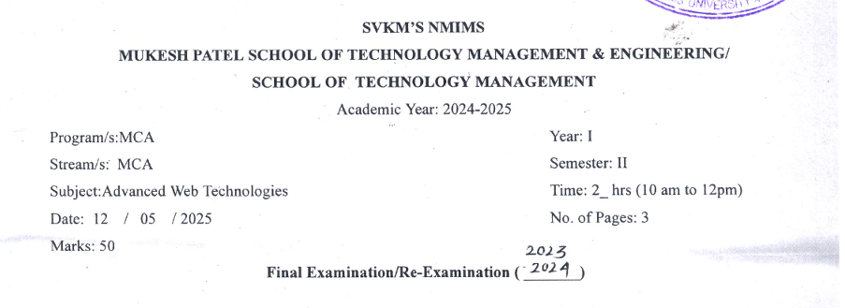
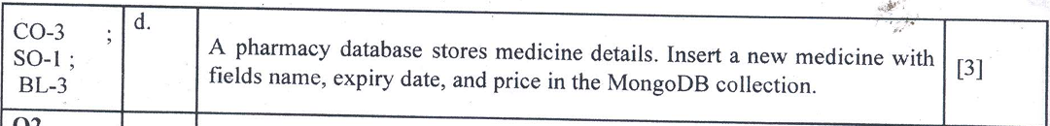
Mongosh shell
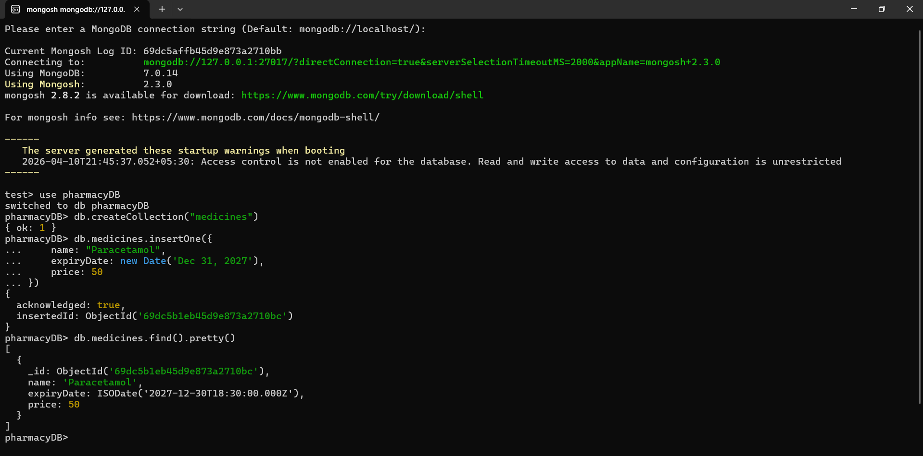
Insert Single Medicine Document
View Inserted Data
MongoDB Compass
{
"name": "Paracetamol",
"expiryDate": ISODate("2027-12-31T00:00:00.000Z"),
"price": 50
}
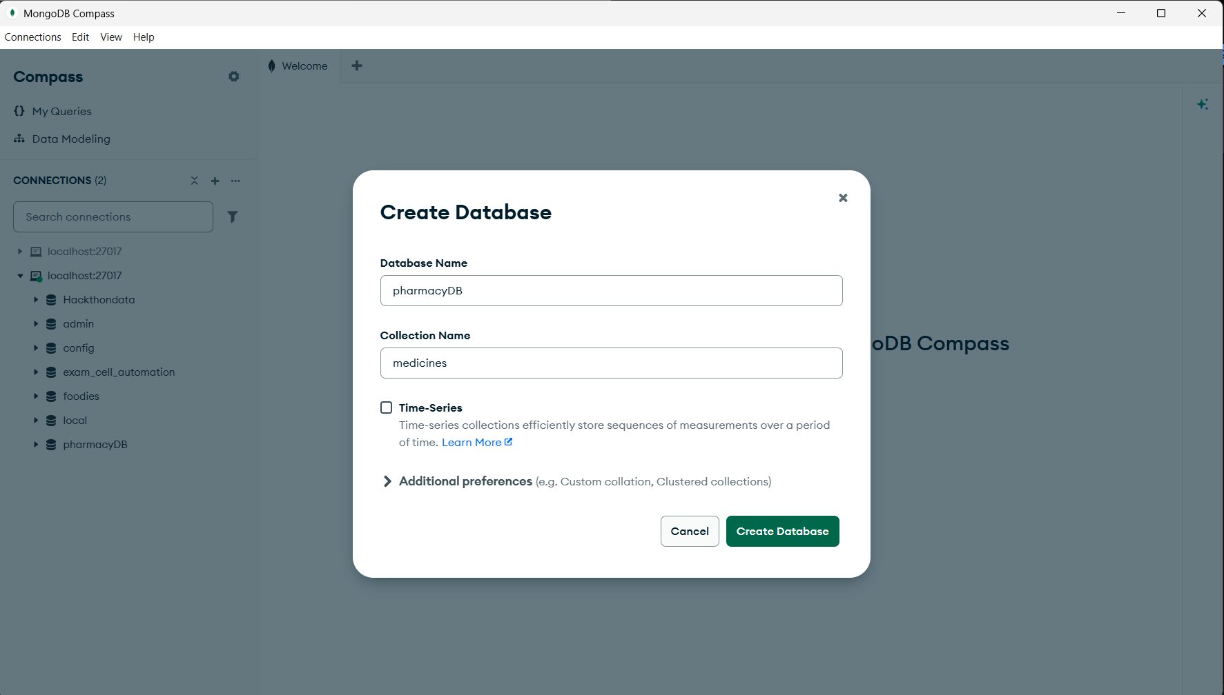
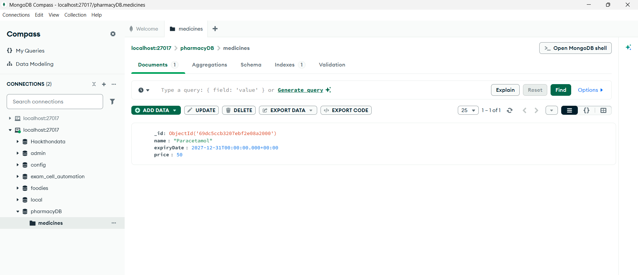

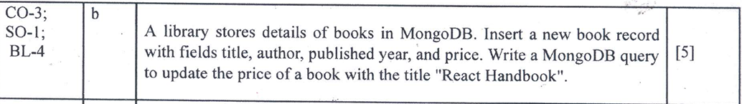 Mongosh shell

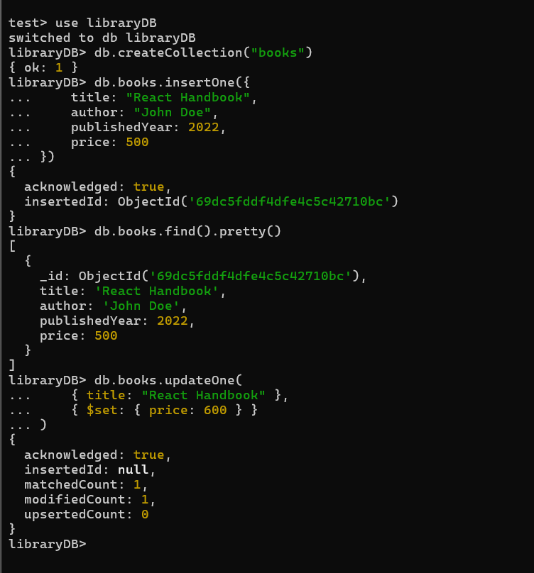
Switch / Create Database
Create collection
Insert a new book document
View Inserted data
Update price of book

MongoDB Compass
Inserting
{
"title": "React Handbook",
"author": "John Doe",
"publishedYear": 2022,
"price": 500
}
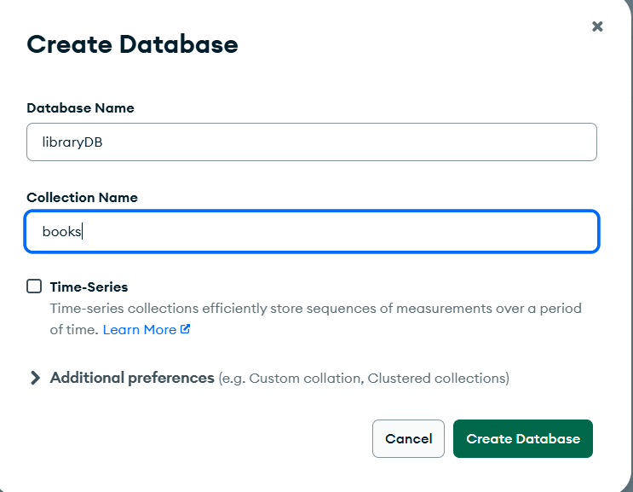
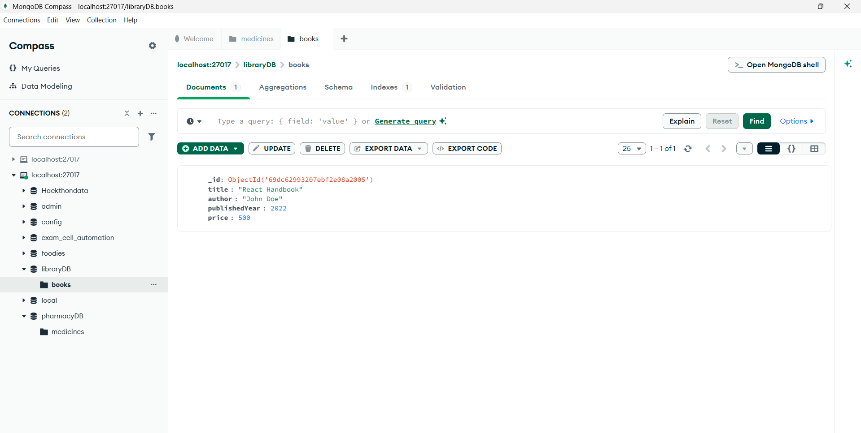
Update Document in Compass
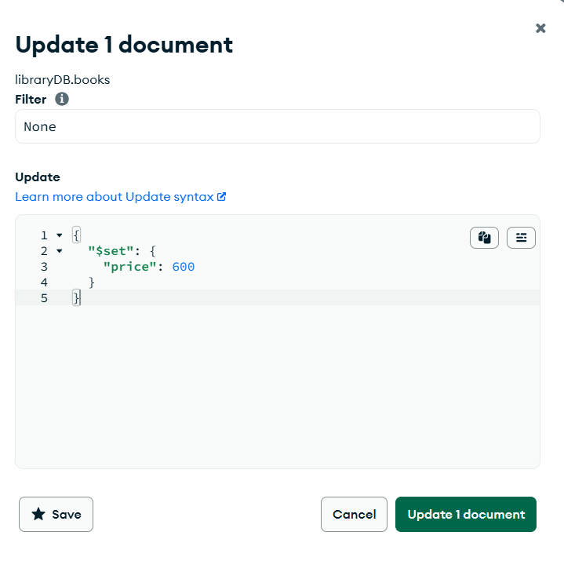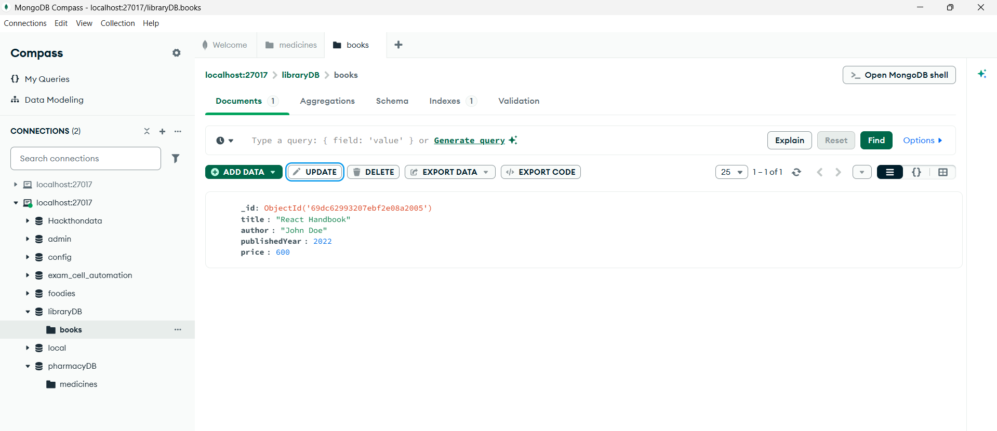
Click on this to update

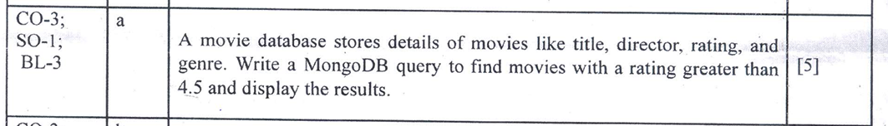
Mongosh shell
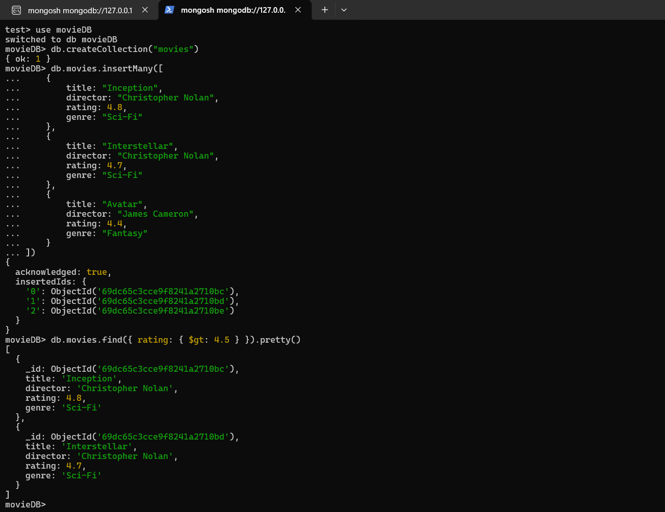
Find Movies with Rating > 4.5
- Used $gt operator to filter rating > 4.5

Insert Documents
MongoDB Compass
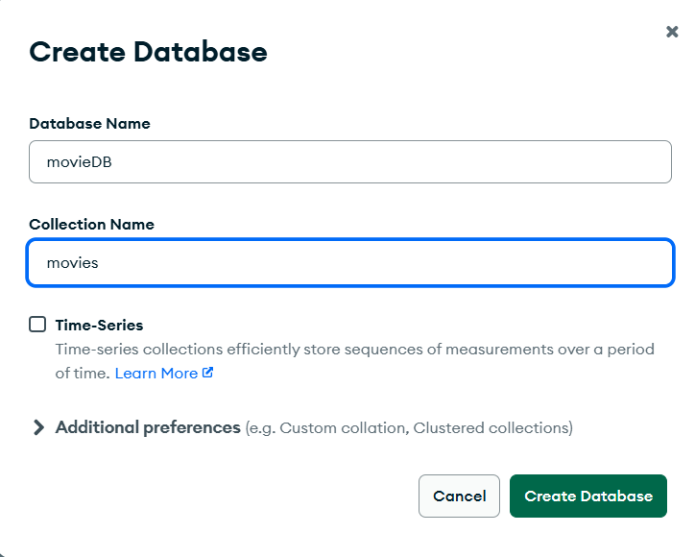
{
"title": "Avatar",
"director": "James Cameron",
"rating": 4.4,
"genre": "Fantasy"
}
{
"title": "Interstellar",
"director": "Christopher Nolan",
"rating": 4.7,
"genre": "Sci-Fi"
}

{
"title": "Inception",
"director": "Christopher Nolan",
"rating": 4.8,
"genre": "Sci-Fi"
}

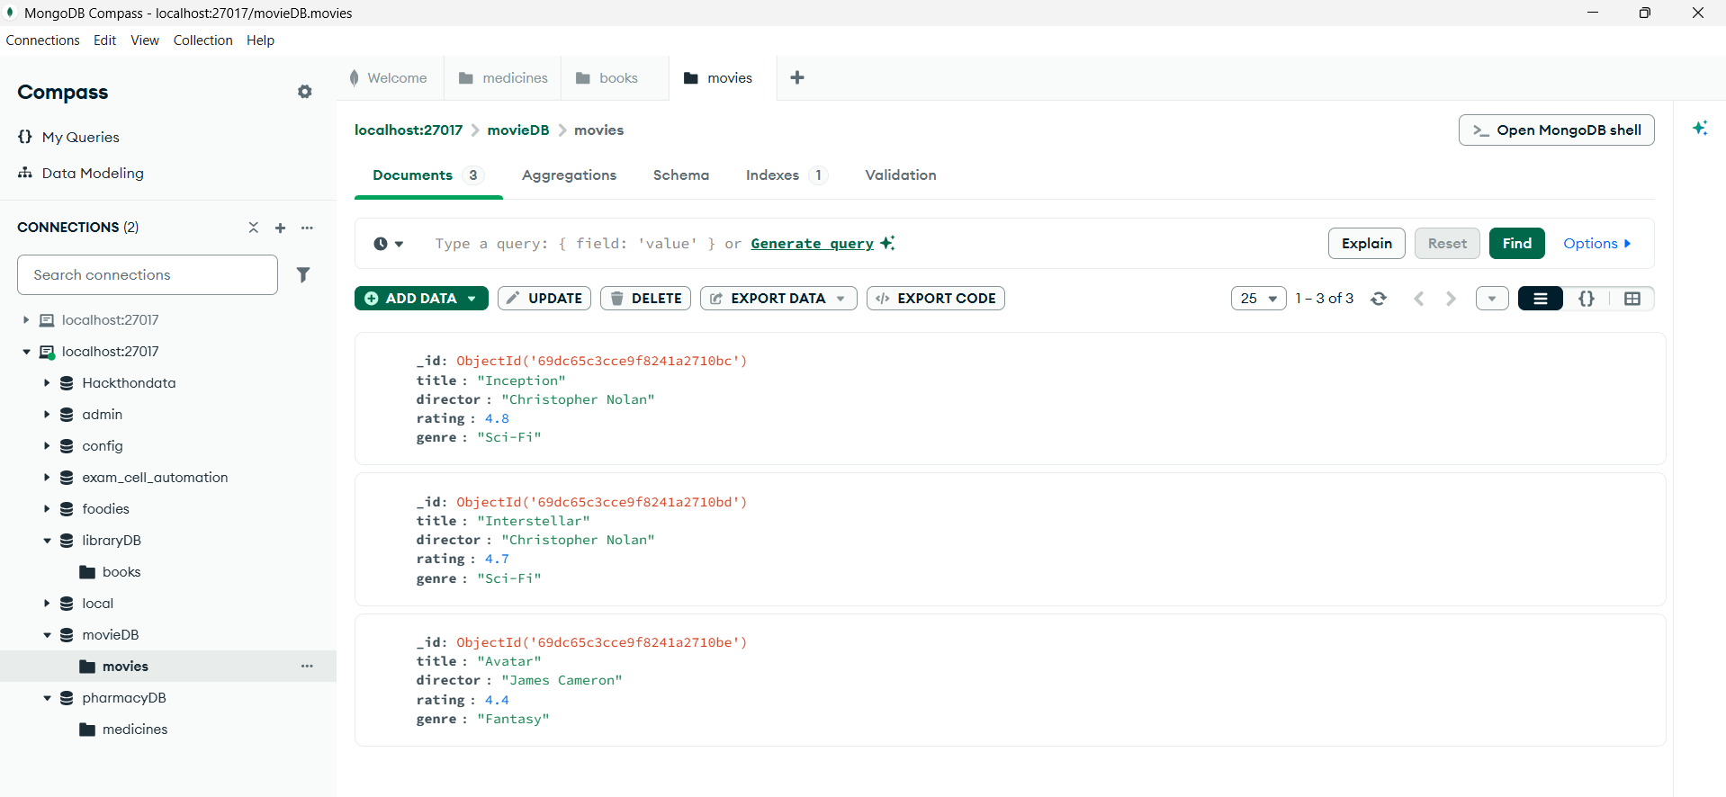
• Click Insert Document
• Add multiple documents one by one:

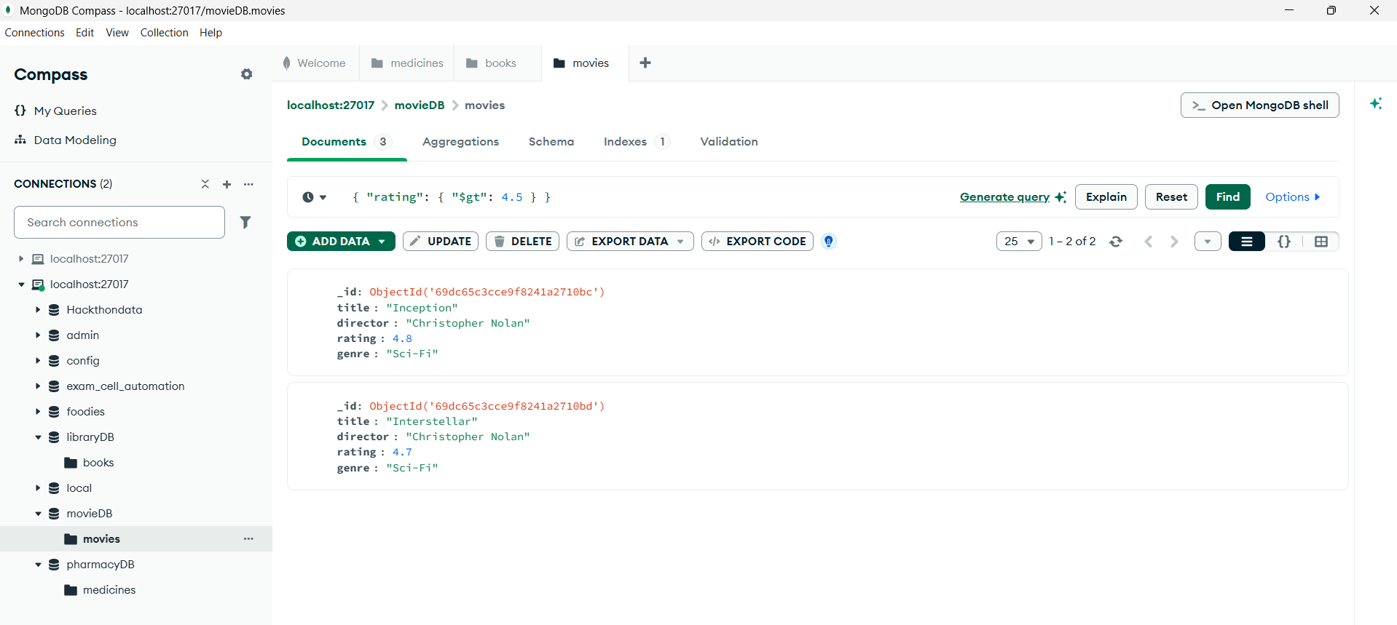
Find Movies with Rating > 4.5
- Also write the query here and click on find
- { "rating": { "$gt": 4.5 } }
